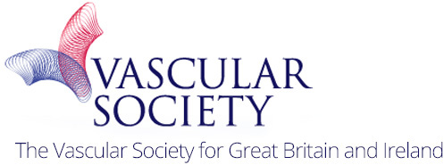

Medical Student Essay Questions

VSAGM

November 2017

Format

- You can choose to enter the essay prize session by entering original work, in answer to one of the three questions detailed below

- You can only enter one piece of work each

- The essay, literature review and discussion are limited to 1500 words, excluding references

- The essay should be written, presented and referenced (Vancouver style) accordingly

- Essays will be marked from a standardized marking scheme

- Submissions will be marked by a panel convened by the Vascular Society Council and the Rouleaux Executive Committee in a blinded manner and scores collated

- An acknowledgment of entry will be sent to all participants, with a certificate of commendation for those scoring highly. The top score from each essay question will be awarded a winning certificate and a cash prize at the VSAGM in November 2017. They will also be printed in the VS newsletter and on the Rouleaux website.

- There will be free registration to the VSAGM for all entrants and the opportunity to take part in a medical student training day.

- Please submit to http://www.rouleauxclub.com/forms/essay/

Questions

- HISTORICAL

What have been the most important advances in vascular surgery in the last century and why?

- RESEARCH & AUDIT

Describe an original piece of audit or research work you have conducted in vascular surgery, how and why this will change practice.

- CLINICAL

Amputation: A Cinderella service? What can be done to improve patient outcomes and mortality in major lower limb amputations?

