Essay 4

Lower Limb Amputation, Moving Forward from a Cinderella Service

Introduction
Across 2014/2015, there were 5,318 major unilateral lower limb amputations in the United Kingdom (UK) reported via The National Vascular Registry.(1) Major lower limb amputation has a 30 day mortality rate of 4-22%.(3) The National Confidential Enquiry into Patient Outcome and Death (NCEPOD) reported this to be 12% in 2014 - double that of an elective aortic aneurysm repair, for which there has been a recognised quality improvement programme nationally.(4, 5) This is generally due to a combination of patient comorbidity and the advanced nature of their arterial disease. For example, with respect to below knee amputation (BKA), significant comorbidities include diabetes (67%), hypertension (60%), ischaemic heart disease (38%), and chronic renal disease (22%).(1)
The need for service improvement is well recognised - The Vascular Society of Great Britain and Ireland (VSGBI) published a Best Care Pathway in 2010 which offered objective measures to reduce mortality and improve patient care. This was later updated in 2016.(2) Additionally, the NCEPOD published a report in 2014 detailing recommendations that echoed that of the VSGBI.(4) For example, the presence of consultant vascular surgeons and anaesthetists during lower limb amputations.
A recent national training survey undertaken by the UK vascular trainee society (Rouleaux club) demonstrated that despite three national reports, the majority of UK hospitals were not adopting best practice. The Rouleaux club utilised an electronic 40-question survey sent to 150 Rouleaux members addressing the adoption of the VSGBI 2010 recommendations. Uptake of the recommendations was poor, with as few as 10% of respondents reporting involvement of the Pain Team in review of the patients. Further to this, only 28% of trainees reported the use of an amputation pathway.
The mortality and morbidity associated with lower limb amputation requires intervention in a similar fashion to earlier efforts with aortic aneurysm and other high risk surgeries e..g emergency laparotomy. Clear guidelines are available in order to reduce this. However, local care pathways have not yet been established.
This is a national problem but one which requires trusts to produce workable local solutions. The only published amputation care pathway comes from Harlow in the UK.(6) However, this pathway did not incorporate all of the VSGBI recommendations. This article formed a stimulus to address amputation practices at [hospital name] with a view to designing a guideline that could be adapted by other trusts looking to do the same.

Identifying Areas for Improvement
The Amputation Quality Improvement Programme (QIP) at [hospital name] aimed to assess compliance to the VSGBI recommendations (Figure 1) in addition to producing a pathway template that could be modified for use in other units.
Initially, an independent observer assessed the care of 10 consecutive patients requiring a lower limb amputation in a large Vascular Unit. Pre-operatively, relevant members of the Multidisciplinary Team (MDT) did not review the patients (Figure 2). None of the audited patients received a diabetic pre-operative assessment despite diabetes being present in 57% of patients undergoing lower limb amputation.(1) Furthermore, as few as 40% of cases were reviewed by a physiotherapist.
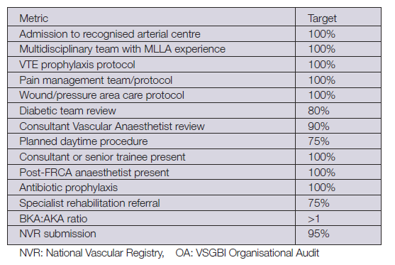
Amputations were performed by senior staff (FRCS holders) in only 30% of cases (Figure 3), with no consultant surgeons present for any of the high-risk cases (V-POSSUM predicted mortality >10%). However, senior anaesthetists were present for all cases. Above Knee Amputation (AKA) was performed in 50% of cases - borderline for fulfilling a BKA:AKA ratio of >1. Elective operations were performed in 60% of cases. Postoperatively, 30% of cases did not have any review from the Pain Team, with a result that patients experienced moderate-to-severe pain for up to 5 days post-operatively. Overall, [hospital name] was not compliant with VSGBI recommendations (Table 1).
Figure 1: Metric standards for evaluation of amputation care from the VSGBI Best Practice Clinical Care Pathway for Major Amputation Surgery.(2)

Figure 2: Percentage of patients assessed pre-operatively by the relevant members of the MDT at [hospital name].

Figure 3: Percentages of cases with senior grade surgeons and anaesthetists present during surgery at [hospital name].

Table 1: Summary of compliance for the [hospital name] to VSGBI 2016 quality standards.
Quality Standard | % Achieved
Venous thromboembolism prophylaxis | 100%
Pain team | 50%
Pressure areas | 100%
Diabetic team | 0%
Vascular anaesthetist | 70%
Elective list | 60%
Consultant/senior surgeon | 30%
Antibiotics | 100%
Physiotherapy & gymnasium | 70%
BKA:AKA ratio | 1

Design of a New Care Pathway
As part of the QIP, the MDT formulated a new care pathway encompassing the recommendations of the VSGBI Best Clinical Care Pathway.(2)
Relevant stakeholders of the MDT met to discuss the design and implementation of a new care pathway. Central to this was communication - this involved meeting face-to-face, sharing contact details and forming group email platforms that included all members of the MDT. Audit presentation at the Vascular and Anaesthetic MDT meetings ensured clear understanding of the current issues amongst key stakeholders. Following these discussions, the Vascular Amputation Acute Care Pathway was developed (Figure 4). Practical-based training sessions on the placement of peripheral nerve catheters were organised for Vascular surgeons and Anaesthetists to increase their utilisation in patients not suitable for epidural anaesthesia. Responsible for re-auditing was the assigned Lower Limb Champion, a Vascular Consultant working within the unit.
An initiating step in the Vascular Amputation Acute Care Pathway is a notifying email sent to all of the stakeholders to inform the relevant members of the MDT that an amputation is planned. This prompts review from the Physiotherapist, Diabetes Team, Vascular, Anaesthetist, and Pain Team. Further to this, all the relevant contact details are listed on the care pathway to ensure clear communication with the MDT. The pathway also prompts booking of the patient onto an elective list with post-operative High-Dependency Unit care. Additionally, the patient will be supplied with information regarding their upcoming amputation – this will soon include video-information provided by previous patients that have undergone lower limb amputations.
Post-operative pain is implicated in the development of phantom limb pain.(7) Pre-operative placement of epidural anaesthesia 48-hours before amputation reduces the incidence of phantom limb pain and can be used as intra-operative anaesthesia in addition to post-operative analgesia.(8) However, a significant proportion of patients undergoing amputations are on anti-coagulation therapy, in these cases epidural anaesthesia is contraindicated.(1)
When epidural anaesthesia is not possible, the use of a peripheral nerve catheter offers a safe and effective way to provide local anaesthesia whilst reducing total opioid use(9) - this is beneficial in patients with comorbid chronic renal failure in preventing opioid accumulation. Knowledge of peripheral nerve catheters is poor and they are currently not being utilised.

The care pathway clearly illustrates the contraindications to epidural anaesthesia. This results in improved recognition of when a peripheral nerve catheter is required - this can then be placed intra-operatively. Appropriate analgesia and adjuncts are also clearly detailed, this should improve prescription of pre-operative pregabalin which has been shown to reduce post-operative phantom limb pain.(10) The escalation pathway for pain management is also clearly identified.
Within the post-operative pathway, it includes specific instructions to encourage patients to begin physiotherapy in the gymnasium whilst their wounds are healing. Initial sessions work on upper-body exercises, enabling the patient to mobilise from chair to bed. Once wound closure has been established the patient should begin working with a training prosthesis.

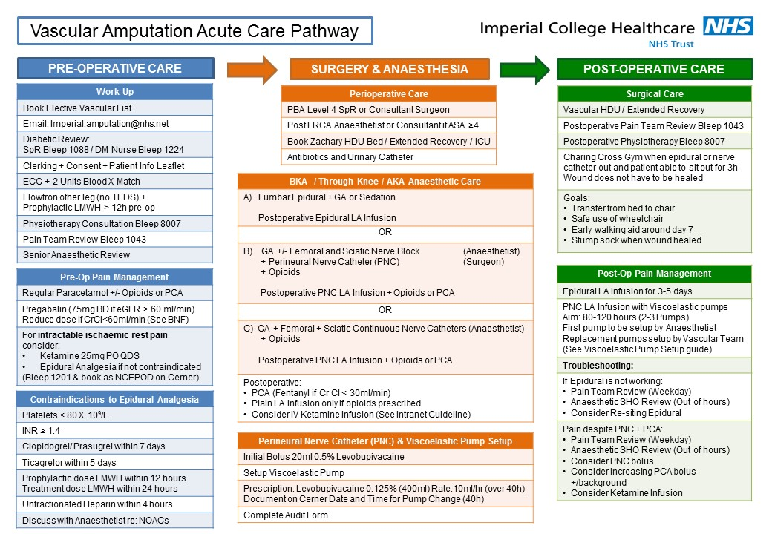
Figure 4: The Vascular Amputation Acute Care Pathway developed by [hospital Name].

Preliminary Results of Vascular Amputation Acute Care Pathway
Since implementation of the Vascular Amputation Acute Care Pathway three patients have undergone lower limb amputations. Preliminary results suggest that service provision is increasingly compliant with the VSGBI recommendations. Senior surgeons (PBA level-IV holder) and Consultant Vascular Anaesthetists were present in all three cases. Amputations were performed on a Vascular list, despite two of these being emergency cases. Adequate provision of either epidural anaesthesia or peripheral nerve catheter was achieved in all three cases. Pain Team and diabetic review was performed in all three cases. However, in one case the Pain Team did not review the patient within the first five post-operative days. A single elective case required re-intervention for stump infection. All three patients are currently awaiting discharge. Although limited conclusions can be drawn from this preliminary data, the initial trends are promising.

Future Direction
The next steps in the second round of the Quality Improvement Pathway include providing open-access videos from a series of amputees reflecting on their experiences during and after their hospital stay. Compliance with VSGBI recommendations for the next 10 consecutive amputations is currently being recorded. Appointment of an amputation champion, who is the lower limb lead Vascular Consultant, will continue to evaluate the QIP.

Conclusion
Lower limb amputation is associated with significant morbidity and mortality. Best care guidelines are not being met. A local solution involving the MDT, consisting of Anaesthetists, Vascular Surgeons, Recovery Staff, Vascular Nursing Staff, Physiotherapy, Occupational Therapy and the Pain Team, as part of an established Amputation Care Pathway is presented. This pathway can be easily adapted in other centres. Results of this pathway will soon be presented.

References
1. Waton S JA, Heikkila K, Cromwell D, Loftus I. National Vascular Registry: 2016 Annual Report. London: The Royal College of Surgeons of England; November 2016.
2. Ireland VSoGBa. A Best Practice Clinical Care Pathway for Major Amputation Surgery. 2016.
3. Van Netten J, Fortington L, Hinchliffe R, Hijmans J. Early post-operative mortality after major lower limb amputation: a systematic review of population and regional based studies. European Journal of Vascular and Endovascular Surgery. 2016;51(2):248-57.
4. Gough MJ JM, Freeth H, Butt A, Mason M,. Lower Limb Amputation: Working Together, A review of the care received by patients who underwent major lower limb amputation due to vascular disease or diabetes. National Confidential Enquiry into Patient Outcome and Death; 2014.
5. Gray A, Landsdown M, Hargraves C, Cullinane M, Tsang C, Smith N. Abdominal Aortic Aneurysm: A service in need of surgery? A report of the National Confidential Enquiry into Patient Outcome and Death. 2005.
6. Lewis J, Dindyal S, Raynor H, Abidia A, Refson J. A “preamputation care pathway” reduces mortality for lower limb amputation. Journal of Vascular Nursing. 2016;34(2):54-8.
7. Hanley MA, Jensen MP, Smith DG, Ehde DM, Edwards WT, Robinson LR. Preamputation pain and acute pain predict chronic pain after lower extremity amputation. The Journal of Pain. 2007;8(2):102-9.
8. Karanikolas M, Aretha D, Tsolakis I, Monantera G, Kiekkas P, Papadoulas S, et al. Optimized Perioperative Analgesia Reduces Chronic Phantom Limb Pain Intensity, Prevalence, and FrequencyA Prospective, Randomized, Clinical Trial. The Journal of the American Society of Anesthesiologists. 2011;114(5):1144-54.
9. Bosanquet D, Glasbey J, Stimpson A, Williams I, Twine C. Systematic review and meta-analysis of the efficacy of perineural local anaesthetic catheters after major lower limb amputation. European Journal of Vascular and Endovascular Surgery. 2015;50(2):241-9.
10. Clarke H, Bonin RP, Orser BA, Englesakis M, Wijeysundera DN, Katz J. The prevention of chronic postsurgical pain using gabapentin and pregabalin: a combined systematic review and meta-analysis. Anesthesia & Analgesia. 2012;115(2):428-42.

Word count:1,499

