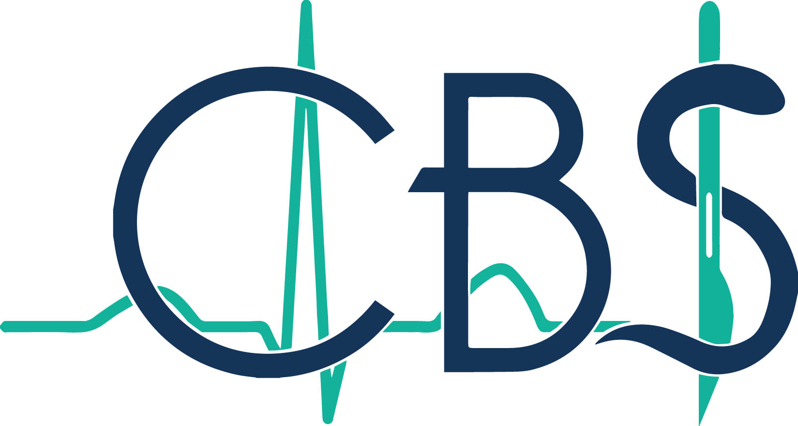

Confederation of British Surgery

How to be a Consultant Surgeon

Places for this meeting are limited to 50
so please book early!

Wednesday 4 December 2019

The Royal College of Surgeons of Edinburgh
85-89 Colmore Row
Birmingham
B3 2BB

Meeting organised by
Professor John MacFie and Mr Richard E Lovegrove

REGISTRATION FORM

Surname: | Forename:
Email address:

Home address:

Home Tel: | Mobile/  Work Tel:

Registration Costs:
CBS members………….£100
Non members…………..£150

BACS Transfer completed [ ] Cheque enclosed [ ] please tick one

If paying by BACS, account number 17284266, sort code 80-22-60
Completed form can be emailed to admin@cbsgb.co.uk

If paying by cheque, please send registration form and cheque made payable to:
Confederation of British Surgery

Postal address: Mrs Carolyn Capps
Confederation of British Surgery
3rd Floor
19 Blythswood Square
Glasgow, G4 4BG

Please note that any cancellation before 25 November 2019 is fully refundable, and after this date is 100% non-refundable.

